


RELATIONSHIP AND SEX EDUCATION POLICY

Document Control
This document has been approved for operation within: | All Trust Establishments
Date effective from | June 2025
Date next review due by | June 2026
Review period | Annually

CONTENTS
1.0 INTRODUCTION 4
2.0 AIMS 4
3.0 STATUTORY REQUIREMENTS 4
4.0 DEFINITION OF RELATIONSHIP AND SEX EDUCATION 5
5.0 OBJECTIVES AND CURRICULUM 5
6.0 ROLES AND RESPONSIBILITY 6
7.0 DELIVERY 7
8.0 PARENTS’ RIGHT TO WITHDRAW 8
9.0 TRAINING 9
10.0 COMPLAINTS PROCEDURE 9
11.0 MONITORING ARRANGEMENTS 9
APPENDIX 1: RELATIONSHIPS AND SEX EDUCATION CURRCIULUM MAP 10
APPENDIX 2: WHAT STUDENTS SHOULD KNOW 11
APPENDIX 3: PARENT FORM: WITHDRAWAL FROM SEX EDUCATION WITHIN RSE 16

INTRODUCTION
1.1 Our school recognises the importance that RSE can play in contributing to the development of healthy young people and this policy is designed to ensure that our students have access to all the teaching and resources that are required to enable them to make prudent judgements about sex and relationships.

2.0 AIMS
2.1 The aims of relationships and sex education (RSE) at our school are to:
- Provide a framework in which sensitive discussions can take place
- Prepare students for puberty, and give them an understanding of sexual development and the importance of health and hygiene
- Help students develop feelings of self-respect, confidence, and empathy
- Create a positive culture around issues of sexuality and relationships
- Teach students the correct vocabulary to describe themselves and their bodies

2.2 The objective of RSE is to help and support young people through their physical, emotional, and moral development. A successful programme, firmly embedded in PSHE, will help young people learn to respect themselves and others and move with confidence from childhood through adolescence into adulthood. This is especially important given the findings of the OFSTED review of Sexual Abuse and Harassment in schools and colleges.

2.3 The school will aim to:
- Foster self-esteem, self-awareness, and a sense of personal moral responsibility
- Encourage self-respect and consideration for others
- Help develop skills in communication, decision-making and assertiveness
- Prepare students to avoid unnecessary risks and dangers

3.0 STATUTORY REQUIREMENTS
3.1 As a secondary academy school we must provide RSE to all students as per section 34 of the Children and Social work act 2017.

3.2 In teaching RSE, we are required by our funding agreements to have regard to guidance issued by the secretary of state as outlined in section 403 of the Education Act 1996. This includes recent and updated guidance from the Department for Education around Sexual Violence and sexual Harassment in schools and colleges and found in Keeping Children Safe in Education Part 5.

At Burnley High School we teach RSE as set out in this policy.

3.3 Our school pays due regard to the legal requirements around political impartiality when delivering its RSE curriculum, particularly when working with external organisations or any material produced by them.
3.4 Our school also pays due regard to our requirements under the Equality Act and Public Sector Equality Duty when planning and teaching RSE, to create an inclusive classroom.

DEFINITION OF RELATIONSHIP AND SEX EDUCATION
4.1 RSE is about the emotional, social, and cultural development of students, and involves learning about relationships, sexual health, sexuality, healthy lifestyles, diversity, and personal identity.

4.2 RSE involves a combination of sharing information and exploring issues and values. RSE is not about the promotion of sexual activity.

4.3 RSE is "lifelong learning about physical, moral and emotional development. It is about the understanding of the importance of marriage and family life, stable and loving relationships, respect, love, and care. It is about the teaching of sex, sexuality, and sexual health. It is also about the development of the student's knowledge and understanding of himself/herself as a sexual being, about what it means to be fully human, called to live in a right relationship with oneself, others and being enabled to make moral decisions according to an informed conscience.

OBJECTIVES AND CURRICULUM
5.1 Our curriculum is set out as per Appendix 1 but we may need to adapt it as and when necessary. We have developed the curriculum in consultation with parents, students, and staff, taking into account the age, needs and feelings of students. We will continue to consult with parents, students and staff when reviewing this policy. If students ask questions outside the scope of this policy, teachers will respond in an appropriate manner, so they are fully informed and don’t seek answers online.
For more information about our curriculum, see our curriculum map in Appendix 1.

5.2 The school will endeavour to deliver relationship and sex education within a moral and values framework. This will be done through:
- Promotion of abstinence before the age of consent
- Promotion of committed relationships and the value of family life
- Teaching self-respect, dignity, self-restraint and respect for others
- Promotion of tolerance of all types of relationships, religions, and personal views
- Encourage students to reflect on their own relationships to develop an understanding of themselves, their sexuality and that of others so that their attitudes in relation to sexual activity are caring and responsible
- Ensure that students appreciate the benefits of stable married life and the responsibilities of parenthood
- Help students recognise the physical, emotional, and moral risks of casual and promiscuous sexual behaviour
- Present biological facts in an objective and balanced manner and to use appropriate terminology to enable students to discuss issues without embarrassment or fear of ridicule
- Develop an awareness of an individual's legal responsibilities in relation to sexual behaviour
- Ensure other models of family and relationships are recognised and understood
- Using up to date information and resources
- Ensuring staff are confident in delivering sex education and using specialists to deliver areas of the curriculum where appropriate
- Regular reviewing of the RSE programme to ensure it meets the needs of students

6.0 ROLES AND RESPONSIBILITY
6.1 Headteacher: is responsible for ensuring that RSE is taught consistently across the school, and for managing requests to withdraw students from [non-statutory/non-science] components of RSE.

6.2 Staff:
Staff are responsible for:
- Delivering RSE in a sensitive way
- Modelling positive attitudes to RSE
- Monitoring progress
- Responding to the needs of individual students
- Responding appropriately to students whose parents wish them to be withdrawn from the [non-statutory/non-science] components of RSE

Staff do not have the right to opt out of teaching RSE. Staff who have concerns about teaching RSE are encouraged to discuss this with the headteacher.

6.3 Students: all students should be willing to listen and ask questions whilst being aware that a variety of other views exist regarding moral issues related to RSE. They will be expected to have a concern for, and accept responsibility for, his/her knowledge and understanding of his/her sexual development. The Wider Community: the school will make appropriate use of external agencies and their personnel. All outside speakers and visiting agencies will meet with The Headteacher and Assistant Head to discuss content and delivery of sex education related to topics. They will be made aware of School’s Relationship and Sex Education policy and be expected to work within it. Visiting speakers will always be a way of enhancing the programme not as a substitute for it.

6.4 Parents: recognising that parents are the primary educators of their children; the school will seek to support them in this task. We will ensure that parents are kept informed of RSE within the school, and of our expectations of their children.

6.5 Governors: governors are consulted on the development of the policy and kept informed of RSE within the school.

7.0 DELIVERY
7.1 RSE will be taught as part of the timetabled curriculum in KS3-4, Science and Citizenship curricula. It will also be enhanced through super learning days. For students who are absent during these days catch up sessions will be provided.

7.2 RSE is taught within the personal, social, health and economic (PSHE) education curriculum. Biological aspects of RSE are taught within the science curriculum, and other aspects are included in religious education (RE).

RSE focuses on giving young people the information they need to help them develop healthy, nurturing relationships of all kinds including:
- Families
- Respectful relationships, including friendships
- Online and media
- Being safe
- Intimate and sexual relationships, including sexual health

Topics around Sex Education will be delivered each half term.

Across our secondary academies, RSE focuses on giving young people the information they need to help them develop healthy, nurturing relationships of all kinds including:
- Families
- Respectful relationships, including friendships
- Online and media
- Being safe
- Intimate and sexual relationships, including sexual health
For more information about our RSE curriculum, see Appendices 1 and 2.

7.3 These areas of learning are taught within the context of family life taking care to ensure that there is no stigmatisation of children based on their home circumstances (families can include single parent families, LGBT parents, families headed by grandparents, adoptive parents, foster parents/carers amongst other structures) along with reflecting sensitively that some children may have a different structure of support around them (for example: looked after children or young carers).

7.4 Use of external organisations and materials
We will make sure that an agency and any materials used are appropriate and in line with our legal duties around political impartiality.

The school remains responsible for what is said to students. This includes making sure that any speakers, tools and resources used don’t undermine the fundamental British values of democracy, the rule of law, individual liberty, and mutual respect and tolerance of those with different faiths and beliefs.

We will:
- Make appropriate checks and engage with external agencies to make sure that their approach to teaching about RSE is balanced, and it and the resources they intend to use:
- Are age-appropriate
- Are in line with students’ developmental stage

Comply with:
- This policy
- The Teachers’ Standards
- The Equality Act 2010
- The Human Rights Act 1998
- The Education Act 1996

- Only work with external agencies where we have full confidence in the agency, its approach and the resources it uses
- Make sure that any speakers and resources meet the intended outcome of the relevant part of the curriculum
- Review any case study materials and look for feedback from other people the agency has worked with

- Be clear on:
- What they’re going to say
- Their position on the issues to be discussed

- Ask to see in advance any materials that the agency may use
- Know the named individuals who will be there, and follow our usual safeguarding procedures for these people
- Conduct a basic online search and address anything that may be of concern to us, or to parents and carers
- Check the agency’s protocol for taking pictures or using any personal data they might get from a session
- Remind teachers that they can say “no” or, in extreme cases, stop a session
- Make sure that the teacher is in the room during any sessions with external speakers

We won’t, under any circumstances:
- Work with external agencies that take or promote extreme political positions
- Use materials produced by such agencies, even if the material itself is not extreme

8.0 PARENTS’ RIGHT TO WITHDRAW
8.1 Parents have the right to withdraw their children from the [non-statutory/non-science] components of sex education within RSE up to and until 3 terms before the child turns 16. After this point, if the child wishes to receive sex education rather than being withdrawn, the school will arrange this.

8.2 Requests for withdrawal should be put in writing using the form found in Appendix 3 of this policy and addressed to the headteacher.
8.3 A copy of withdrawal requests will be placed in the student’s educational record. The headteacher will discuss the request with parents and take appropriate action.
8.4 Alternative work will be given to students who are withdrawn from sex education.

9.0 TRAINING
9.1 Staff are trained on the delivery of RSE as part of their induction and it is included in our continuing professional development calendar.
9.2 The PSHE Co-ordinator will also invite visitors from outside the school, such as school nurses or sexual health professionals, to provide support and training to staff teaching RSE.

10.0 COMPLAINTS PROCEDURE
10.1 Any complaints about the sex education curriculum should be made to the Headteacher to be dealt with in line with the school’s complaint policy.

11.0 MONITORING ARRANGEMENTS
11.1 The delivery of RSE is monitored by the Headteacher and the Assistant Heads through:
- Learning walks
- Student voice
- Work scrutinies

Students’ development in RSE is monitored by class teachers as part of our internal assessment systems.

APPENDIX 1: RELATIONSHIPS AND SEX EDUCATION CURRCIULUM MAP
KS3 – Personal Development Curriculum Map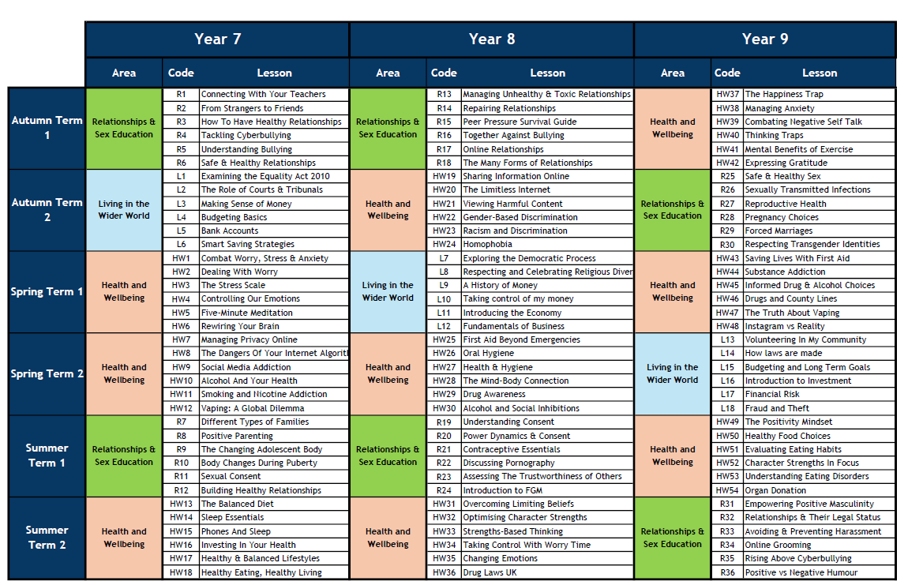
KS4 Personal Development – Curriculum Map
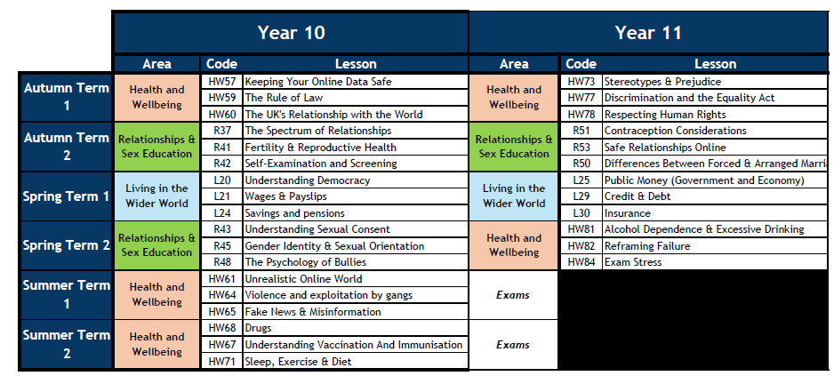

APPENDIX 2: WHAT STUDENTS SHOULD KNOW

BY THE END OF SECONDARY EDUCATION STUDENTS SHOULD KNOW

TOPIC | STUDENTS SHOULD KNOW
Families | - That there are different types of committed, stable relationships  - How these relationships might contribute to human happiness and their importance for bringing up children  - What marriage is, including their legal status e.g. that marriage carries legal rights and protections not available to couples who are cohabiting or who have married, for example, in an unregistered religious ceremony  - Why marriage is an important relationship choice for many couples and why it must be freely entered into  - The characteristics and legal status of other types of long-term relationships  - The roles and responsibilities of parents with respect to raising of children, including the characteristics of successful parenting  - How to: determine whether other children, adults or sources of information are trustworthy: judge when a family, friend, intimate or other relationship is unsafe (and to recognise this in others’ relationships); and, how to seek help or advice, including reporting concerns about others, if needed
Respectful relationships, including friendships | - The characteristics of positive and healthy friendships (in all contexts, including online) including: trust, respect, honesty, kindness, generosity, boundaries, privacy, consent and the management of conflict, reconciliation and ending relationships. This includes different (non-sexual) types of relationship  - Practical steps they can take in a range of different contexts to improve or support respectful relationships  - How stereotypes, in particular stereotypes based on sex, gender, race, religion, sexual orientation or disability, can cause damage (e.g. how they might normalise non-consensual behaviour or encourage prejudice)  - That in school and in wider society they can expect to be treated with respect by others, and that in turn they should show due respect to others, including people in positions of authority and due tolerance of other people’s beliefs  - About different types of bullying (including cyberbullying), the impact of bullying, responsibilities of bystanders to report bullying and how and where to get help  - That some types of behaviour within relationships are criminal, including violent behaviour and coercive control  - What constitutes sexual harassment and sexual violence and why these are always unacceptable  - The legal rights and responsibilities regarding equality (particularly with reference to the protected characteristics as defined in the Equality Act 2010) and that everyone is unique and equal
Online and media | - Their rights, responsibilities and opportunities online, including that the same expectations of behaviour apply in all contexts, including online  - About online risks, including that any material someone provides to another has the potential to be shared online and the difficulty of removing potentially compromising material placed online  - Not to provide material to others that they would not want shared further and not to share personal material which is sent to them What to do and where to get support to report material or manage issues online  - The impact of viewing harmful content  - That specifically sexually explicit material e.g. pornography presents a distorted picture of sexual behaviours, can damage the way people see themselves in relation to others and negatively affect how they behave towards sexual partners  - That sharing and viewing indecent images of children (including those created by children) is a criminal offence which carries severe penalties including jail  - How information and data is generated, collected, shared and used online
Being safe | - The concepts of, and laws relating to, sexual consent, sexual exploitation, abuse, grooming, coercion, harassment, rape, domestic abuse, forced marriage, honour-based violence and FGM, and how these can affect current and future relationships  - How people can actively communicate and recognise consent from others, including sexual consent, and how and when consent can be withdrawn (in all contexts, including online)
Intimate and sexual relationships, including sexual health | - How to recognise the characteristics and positive aspects of healthy one-to-one intimate relationships, which include mutual respect, consent, loyalty, trust, shared interests and outlook, sex and friendship  - That all aspects of health can be affected by choices they make in sex and relationships, positively or negatively, e.g. physical, emotional, mental, sexual and reproductive health and wellbeing  - The facts about reproductive health, including fertility and the potential impact of lifestyle on fertility for men and women  - That there are a range of strategies for identifying and managing sexual pressure, including understanding peer pressure, resisting pressure and not pressurising others  - That they have a choice to delay sex or to enjoy intimacy without sex  - The facts about the full range of contraceptive choices, efficacy and options available  - The facts around pregnancy including miscarriage  - That there are choices in relation to pregnancy (with medically and legally accurate, impartial information on all options, including keeping the baby, adoption, abortion and where to get further help)  - How the different sexually transmitted infections (STIs), including HIV/AIDs, are transmitted, how risk can be reduced through safer sex (including through condom use) and the importance of and facts about testing  - About the prevalence of some STIs, the impact they can have on those who contract them and key facts about treatment  - How the use of alcohol and drugs can lead to risky sexual behaviour  - How to get further advice, including how and where to access confidential sexual and reproductive health advice and treatment

APPENDIX 3: PARENT FORM: WITHDRAWAL FROM SEX EDUCATION WITHIN RSE

TO BE COMPLETED BY PARENTS
Name of child |  | Class
Name of parent |  | Date
Reason for withdrawing from sex education within relationships and sex education
Any other information you would like the school to consider
Parent signature

TO BE COMPLETED BY THE SCHOOL
Agreed actions from discussion with parents

