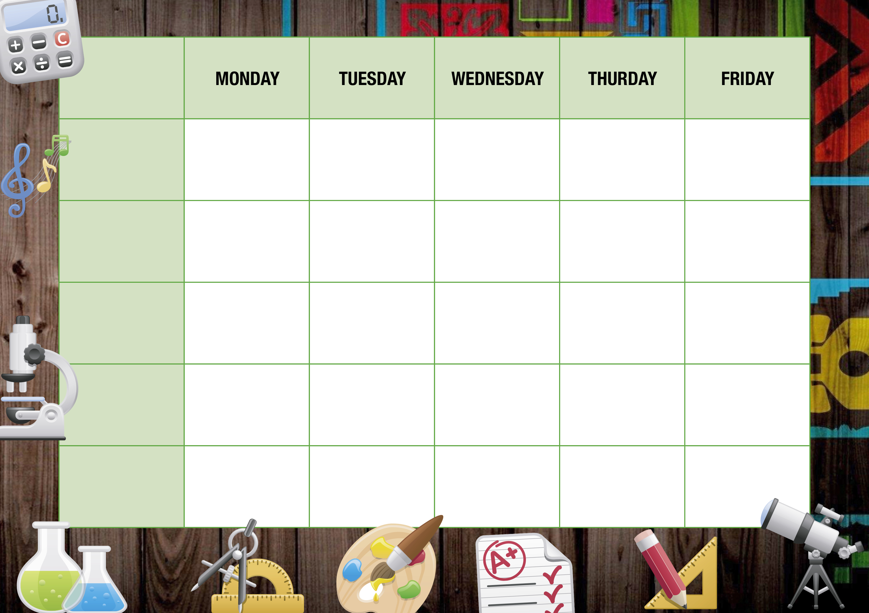

Jacket potatoes daily

Selected fresh Sandwiches, Wraps,

Baguettes,

BBQ Chicken Strips with Wedges & Beans

Chicken & Bacon Pasta Bake

Chicken Burrito

Cheese & Onion Pie

With Mash & Beans

Fish & Chips with Peas

Cheese Swirl with Wedges & Beans

Vegetarian Curry with Rice

Veggie Sausage with Mash & Beans

Veggie Burrito

Veggie Pizza

Tomato & Basil Pasta

Tuna & Cheese Sub Roll Melt

Tomato & Basil Pasta

Southern Fried Chicken Wrap

Tomato & Basil Pasta

Tuna Pasta Bake

Tomato & Basil Pasta

Sweet & Sour Chicken with Rice

Tomato & Basil Pasta

Meat Feast Pizza

Jacket potatoes daily

Selected fresh Sandwiches, Wraps,

Baguettes,

Jacket potatoes daily

Selected fresh Sandwiches, Wraps,

Baguettes,

Jacket potatoes daily

Selected fresh Sandwiches, Wraps,

Baguettes,

Jacket potatoes daily

Selected fresh Sandwiches, Wraps,

Baguettes,

Fresh fruit pots & yoghurts.

Assorted cakes & biscuits

Fresh fruit pieces & pots yoghurts.

Assorted home-bakes & cakes

Fresh fruit pieces & pots yoghurts.

Assorted home-bakes & cakes

Fresh fruit pieces & pots yoghurts.

Assorted home-bakes & cakes

Fresh fruit pieces & pots yoghurts.

Assorted home-bakes & cakes

**HOT MAIN**

**Week 3**

**VEGETARIAN**

**GRAB & GO.**

**SANDWICHES**

**DESSERTS**